here's an example of JMP instruction:

org 100h

mov ax, 5 ; set ax to 5.

mov bx, 2 ; set bx to 2.

jmp calc ; go to 'calc'.

back: jmp stop ; go to 'stop'.

calc:

add ax, bx ; add bx to ax.

jmp back ; go 'back'.

stop:

ret

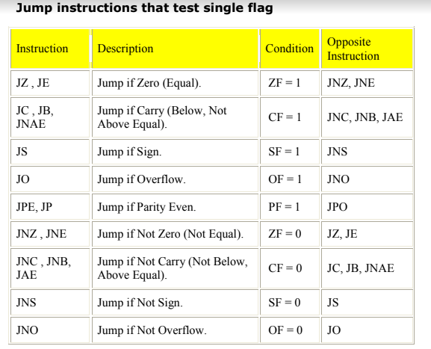

PUSH and POP instruction

ORG 100h

MOV AX, 1234h

PUSH AX ; store value of AX in stack.

MOV AX, 5678h ; modify the AX value.

POP AX ; restore the original value of

RET

END

#Another use of the stack is for exchanging the values,

here is an example:

ORG 100h

MOV AX, 1212h ; store 1212h in AX.

MOV BX, 3434h ; store 3434h in BX

PUSH AX ; store value of AX in stack.

PUSH BX ; store value of BX in stack.

POP AX ; set AX to original value of BX.

POP BX ; set BX to original value of AX.

RET

END